Question 3

Python script

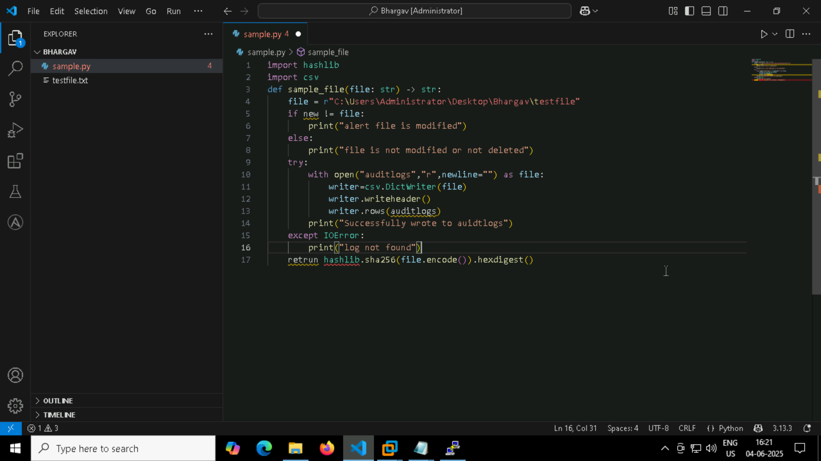

So when I modify the file I will get alert that alert file is modified

output

